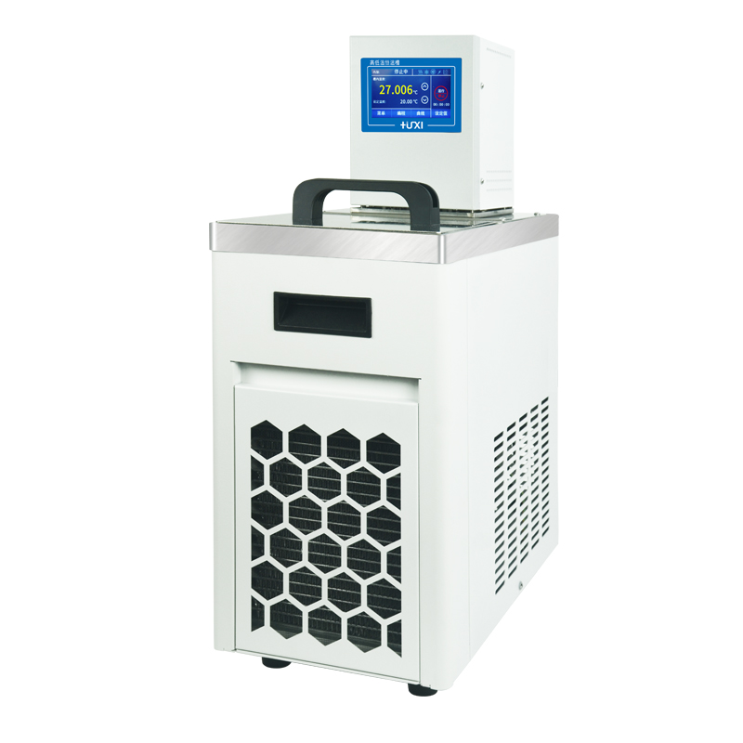

HLC-4008SH High and low temperature thermostat

1、Product application

HLC series vertical high and low temperature constant temperature bath is widely used in biology, chemical industry, chemistry, pharmacy, life sciences, physical testing and other industries, colleges and universities, enterprise quality inspection. For the user experiments and production to provide a hot and cold controlled, uniform and constant temperature field source, the test samples or production of products for constant temperature test or test, can also be used as a direct heating or refrigeration and auxiliary heating or refrigeration of the heat or cold source.
2、Features

- Maintenance-free pressure/suction pump, resistant to fibre and metal particulate matter, while the bath can be stirred horizontally and vertically in both directions for more even mixing;
- Multi-safety protection: low liquid level protection, can be alarmed with light and sound reminders at the same time;
- And liquid or steam contact parts using high-performance stainless steel and high-performance plastics;
- Pt100 temperature sensor for single and two-point temperature calibration;
- Internal circulation, which comes standard with two different heights of cup holders for different cups
- Thermostatic and viscosity testing in the bath;
- External circulation for thermoregulation of the viscometer's water bath jacket, suitable for viscosity testing of samples in a water bath jacket outside the bath;
- The buzzer can be set to silent or audible.
3、Technical Parameters
Product Model | HLC-4008SH
Product No. | 1032074001
Tank volume(L) | 8
Temperature range (℃) | -40~200
Temperature control fluctuation value (℃) | ±0.03
Setting accuracy (℃) | ±0.1
Display precision (℃) | ±0.01
High temperature direct drop | Yes
Circulation mode | Internal and External Circulation
Use of ambient temperature (℃) | 5~32
Power supply voltage (V) | 200~230
Display temperature mode | Touch screen digital display
Setting mode | Touch screen
Safety protection | Low liquid level protection, high temperature protection
Heating power (W) | 2000
Cooling power(W) | 600
Refrigerant | R404A
Water pump flow (L/min) max/rated | 22/15
Lift(M)(Max/Rated) | 3.0/2.0
Circulation interface | 10mm Pagoda Fitting
Tank opening(mm)(WxDxH) | 166*155*150
Overall Dimension(mm)(WxDxH) | 230*400*720

4、Packing List
Name | Qty
Main Host | 1pcs
DN8 connector | 2pcs
M16*1 nut | 2pcs
8*12 insulation pipe | 1.8m*2pcs
Certificate of Conformity (with warranty card) | 1pcs
Instruction manual | 1pcs

